**Background**

During the coronavirus disease 2019 (COVID-19) pandemic, Department of Health teams will go out into the community to screen patients for symptoms, and a history of travel or contacts (using a questionnaire). When necessary, a specimen will be collected for SARS-CoV-2 PCR testing. To determine who should be tested, refer to the latest definition of a person under investigation (PUI) on the NICD website. The testing will either be performed in the community in an accompanying NHLS Mobile Laboratory that has testing equipment on-board, or the specimens will be delivered to an NHLS laboratory for testing.

**Coronavirus disease 2019 (COVID-19)**

**Community Screening and Testing**

**Quick Reference for Health Workers**

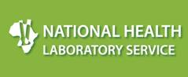

**Reporting**

The community-based screening and testing process typically occurs outside the formal health infrastructure. However for results retrieval and reporting, it is essential to link the laboratory information of the patient to a fixed health facility. It is important to provide the name of the **geographically nearest primary health care (PHC) facility**, and **Community Screen and Test** (CST).

**Specimen collection**

1. Don appropriate PPE
2. Open a sterile flocked swab at the plastic shaft
3. For a nasopharyngeal specimen: Ask the patient to tilt their head back. Estimate the distance from the patient’s nose to the ear. Gently insert swab into the nostril and back (not upwards) to the nasopharynx until slight resistance is met. Rotate swab 2-3 times and hold in place for 2-3 seconds. If resistance is met before fully inserted, remove and try the other nostril.
4. For a mid-turbinate specimen: Ask the patient to tilt their head back (~70 degrees). Gently insert swab less than 2 cm into nostril (until resistance is met at turbinates) and gently rotate several times against nasal wall. Repeat in other nostril using the same swab.
5. For a nasal specimen: Insert the swab at least 1 cm inside the nares and firmly sample the nasal membrane by rotating the swab and leaving in place for 10 to 15 seconds. Sample both nares with same swab.

**Forms to be completed**

1. NHLS N1 PHC Request Form. Send to the laboratory
2. Contact list form. Retain

**Mandatory information to be provided on N1 PHC form**

1. Facility name: Name of geographically nearest PHC facility
2. Service Point: Community Screen and Test or CST
3. Patient information:
   1. Surname and name
   2. Sex
   3. Date of birth
   4. Address
   5. Mobile telephone number
   6. Alternative telephone number
   7. ID number (or passport number) if available
4. Health care worker name, SANC / HPCSA registration number and contact details
5. Specimen type
6. Collection date and time
7. Test required CoV-2 PCR

**NB. Keep one form barcode label for easy result retrieval**

**How to prepare swab for transport**

1. Swab must not be placed in gel transport medium
2. Transport options:
   1. Place swab in the empty dry swab holder
   2. Break at break-point, or cut the swab halfway down its length, and place into an empty sterile container
   3. Break at break-point, or cut the swab halfway down its length, and place into a sterile container with viral transport medium (if available). Close tightly.
3. If scissors are used, wash with soap between use

**NB. Leaking specimens will be rejected**

**Example of a completed N1 PHC request form**

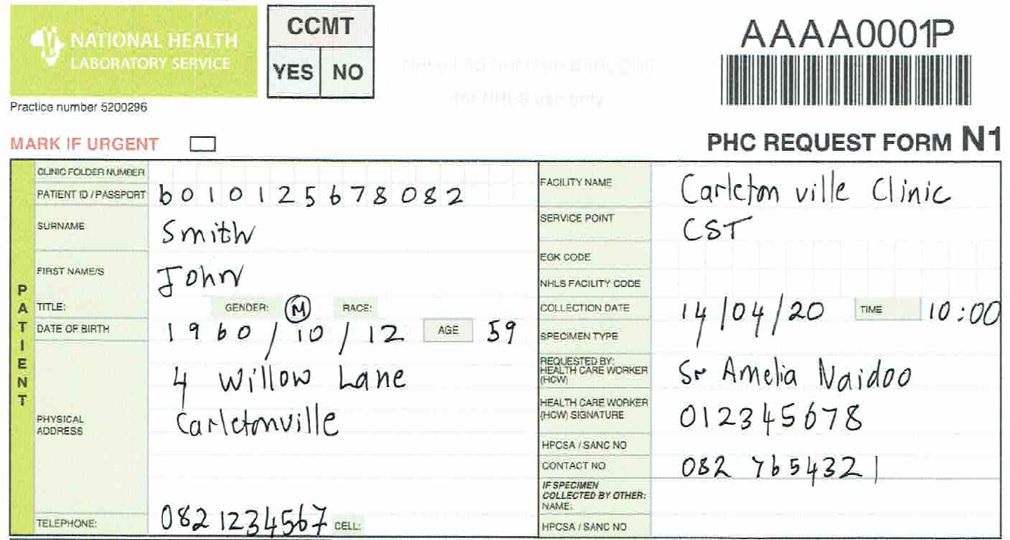

**Labelling and packaging of swab and request form**

1. Label swab with an N1 barcode label
2. Place the swab into a specimen bag and carefully seal it
3. Have a co-worker wearing a clean pair of gloves prepare a biohazard bag, taking care to keep it uncontaminated:
   1. Swab-taker to place the sealed specimen bag into the specimen pocket
   2. Co-worker with clean gloves to carefully seal it
   3. Co-worker with clean gloves to place completed N1 form into the side pocket
4. Place biohazard bag in fridge or cool place awaiting delivery to laboratory or collection by courier

**Specimens required for CoV-2 PCR testing**

Only **one** swab required: preferably nasopharyngeal, else a nasal or nasal mid-turbinate swab. The swab should aim to brush **cells and secretions** off the mucous membranes.

**Recommended swab type**

Flocked (polyester/nylon) or spun fibre (polyester/rayon) swabs with plastic or aluminium shafts should be used.