To: Editors & Health Journalists
Issued by: National Institute for Communicable Diseases
Date: Friday, 13 August 2021

LATEST CONFIRMED CASES OF COVID-19 IN SOUTH AFRICA (13 August 2021)
The National Institute for Communicable Diseases (NICD), a division of the National Health Laboratory Service, continues the monitoring and surveillance of COVID-19 in order to inform the public health response.
Today the institute reports 13,921 new COVID-19 cases that have been identified in South Africa, which brings the total number of laboratory-confirmed cases to 2,582,427. This increase represents a 23% positivity rate. As per the National Department of Health, a further 384 COVID-19 related deaths have been reported, bringing total fatalities to 76,631 to date.
15,487,205 tests have been conducted in both public and private sectors as per the table below.
Sector | Total tested |  | New tested
Private | 8,568,194 | 55% | 27,761 | 46%
Public | 6,919,011 | 45% | 32,777 | 54%
Total | 15,487,205 |  | 60,538

PROVINCIAL BREAKDOWN
The majority of new cases today are from Western Cape (28%), followed by KwaZulu-Natal (24%). Gauteng Province accounted for 15%; Eastern Cape accounted for 8%; Free State and Mpumalanga each accounted for 6% respectively; North West accounted for 5%; Northern Cape accounted for 4%; and Limpopo Province accounted for 3% of today’s new cases. The cumulative number of cases by province is shown in the table below:
Province | Total cases for 12 August 2021 | Adjusted numbers after harmonisation | Updated total cases on 12 August 2021 | New cases on 13 August 2021 | Total cases for 13 August 2021 | Percentage total
Eastern Cape | 239,166 | -1 | 239,165 | 1,180 | 240,345 | 9,3
Free State | 134,905 | 4 | 134,909 | 866 | 135,775 | 5,3
Gauteng | 884,147 | -18 | 884,129 | 2,027 | 886,156 | 34,3
KwaZulu-Natal | 421,153 | 4 | 421,157 | 3,359 | 424,516 | 16,4
Limpopo | 115,421 | 19 | 115,440 | 361 | 115,801 | 4,5
Mpumalanga | 133,240 | 4 | 133,244 | 899 | 134,143 | 5,2
North West | 134,414 | -6 | 134,408 | 701 | 135,109 | 5,2
Northern Cape | 71,460 | -26 | 71,434 | 610 | 72,044 | 2,8
Western Cape | 434,605 | 15 | 434,620 | 3,918 | 438,538 | 17,0
Unknown | 0 | 0 | 0 | 0 | 0 | 0,0
Total | 2,568,511 | -5 | 2,568,506 | 13,921 | 2,582,427 | 100,0

THE 7-DAY MOVING AVERAGE NUMBER OF NEW CASES BY PROVINCE
The total number of cases today (n= 13 921) is lower than yesterday (n= 14 271) but higher than the average number of new cases per day over the 7 preceding days (n=10 207). The 7-day moving average daily number of cases has increased.
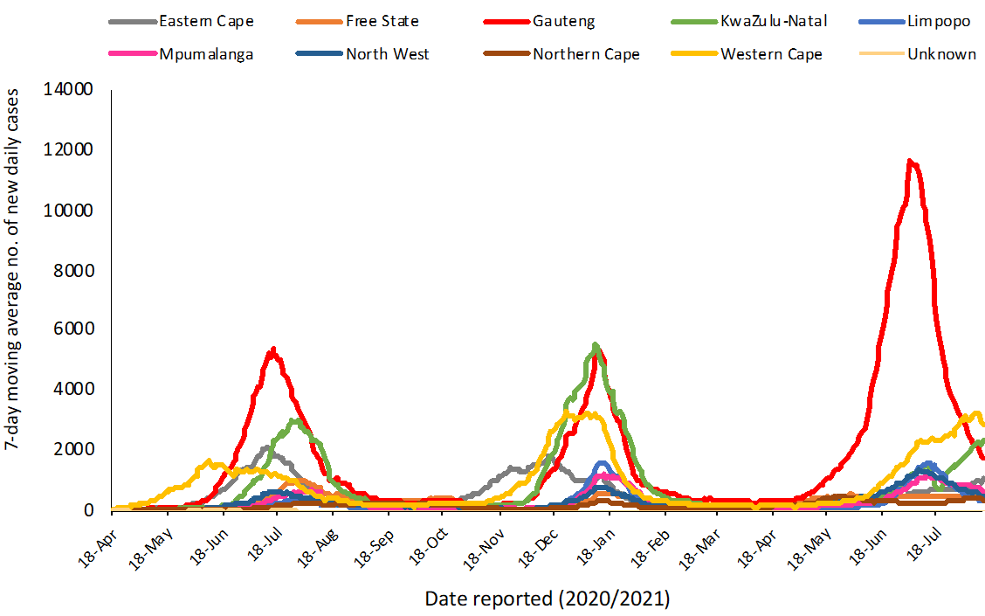

For more detailed information, visit the GIS Dashboard.
HOSPITAL ADMISSIONS
There has been an increase of 594 hospital admissions in the past 24 hours. The following table is a summary of reported COVID-19 admissions by sector.
Sector | Facilities Reporting | Admissions  to Date | Died to Date | Currently Admitted
Private | 257 | 183,244 | 33,076 | 7,381
Public | 411 | 201,716 | 48,942 | 7,206
TOTAL | 668 | 384,960 | 82,018 | 14,587
VACCINE UPDATE
For updates on the national vaccine programme, click here.
Thank you for your interest and remember that adhering to preventative measures limits your risk of contracting and spreading COVID-19. For more information on COVID-19, click here.
Kind regards,
Sinenhlanhla Jimoh, Senior Communications Manager
National Institute for Communicable Diseases

