Heritage Day social media post | 02 October 2023

HTML | Images
As #HeritageMonth draws to a close, we couldn't help but throw an EPIC Diversity Park celebration at our Sandringham offices! We feasted on delicious food, laughed together, and celebrated our heritage with pride on this fun-filled day!  At the NICD, we believe in the power of heritage and diversity. We are stronger together, and we are proud to be a part of this inclusive community.  #HeritageCelebration #DiversityPark | 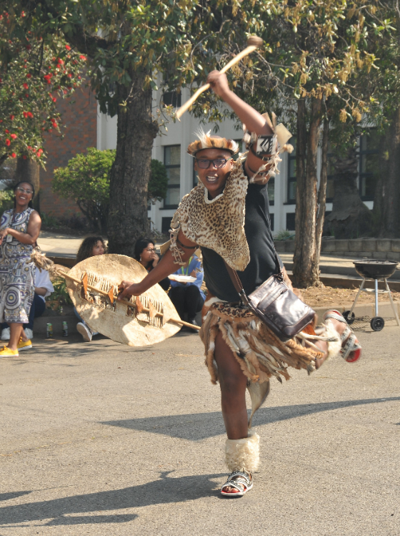  (pic 164)
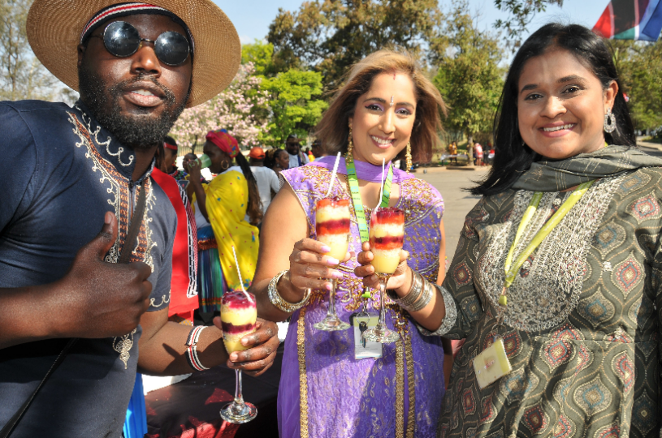

(Pic 191)

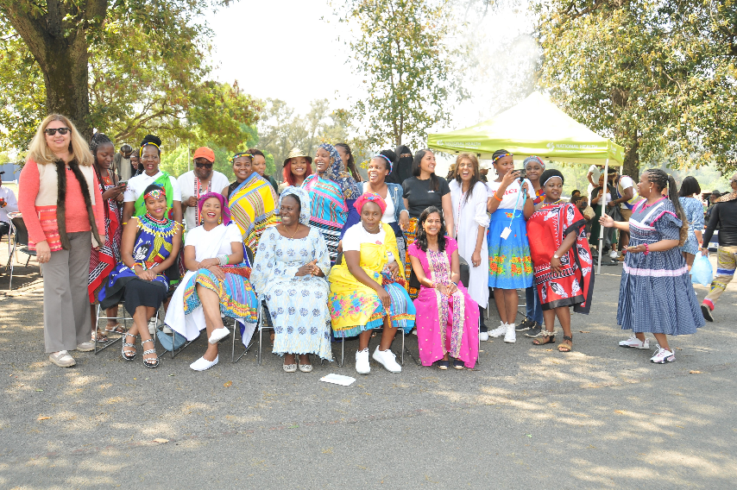

(Pic 106)

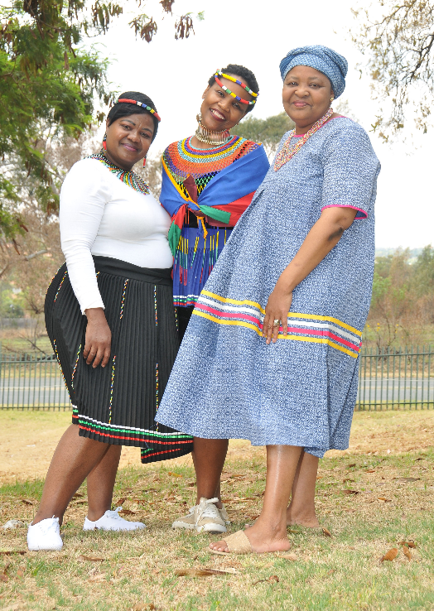

(Pic 17)

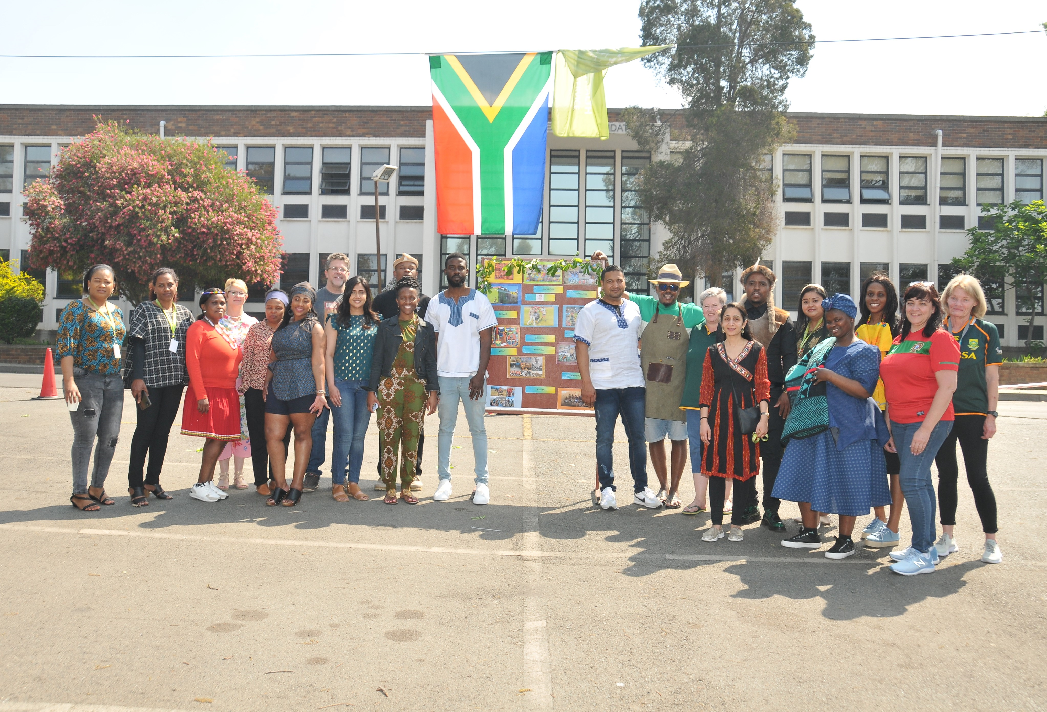

(pic 112)

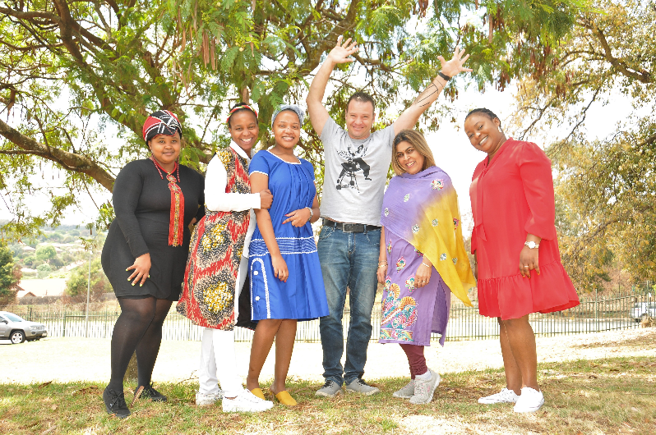

(Pic 7)

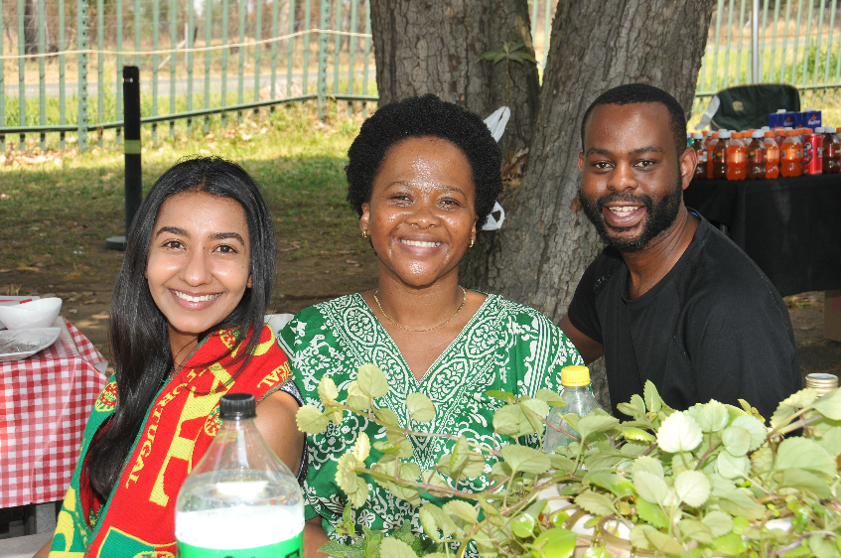

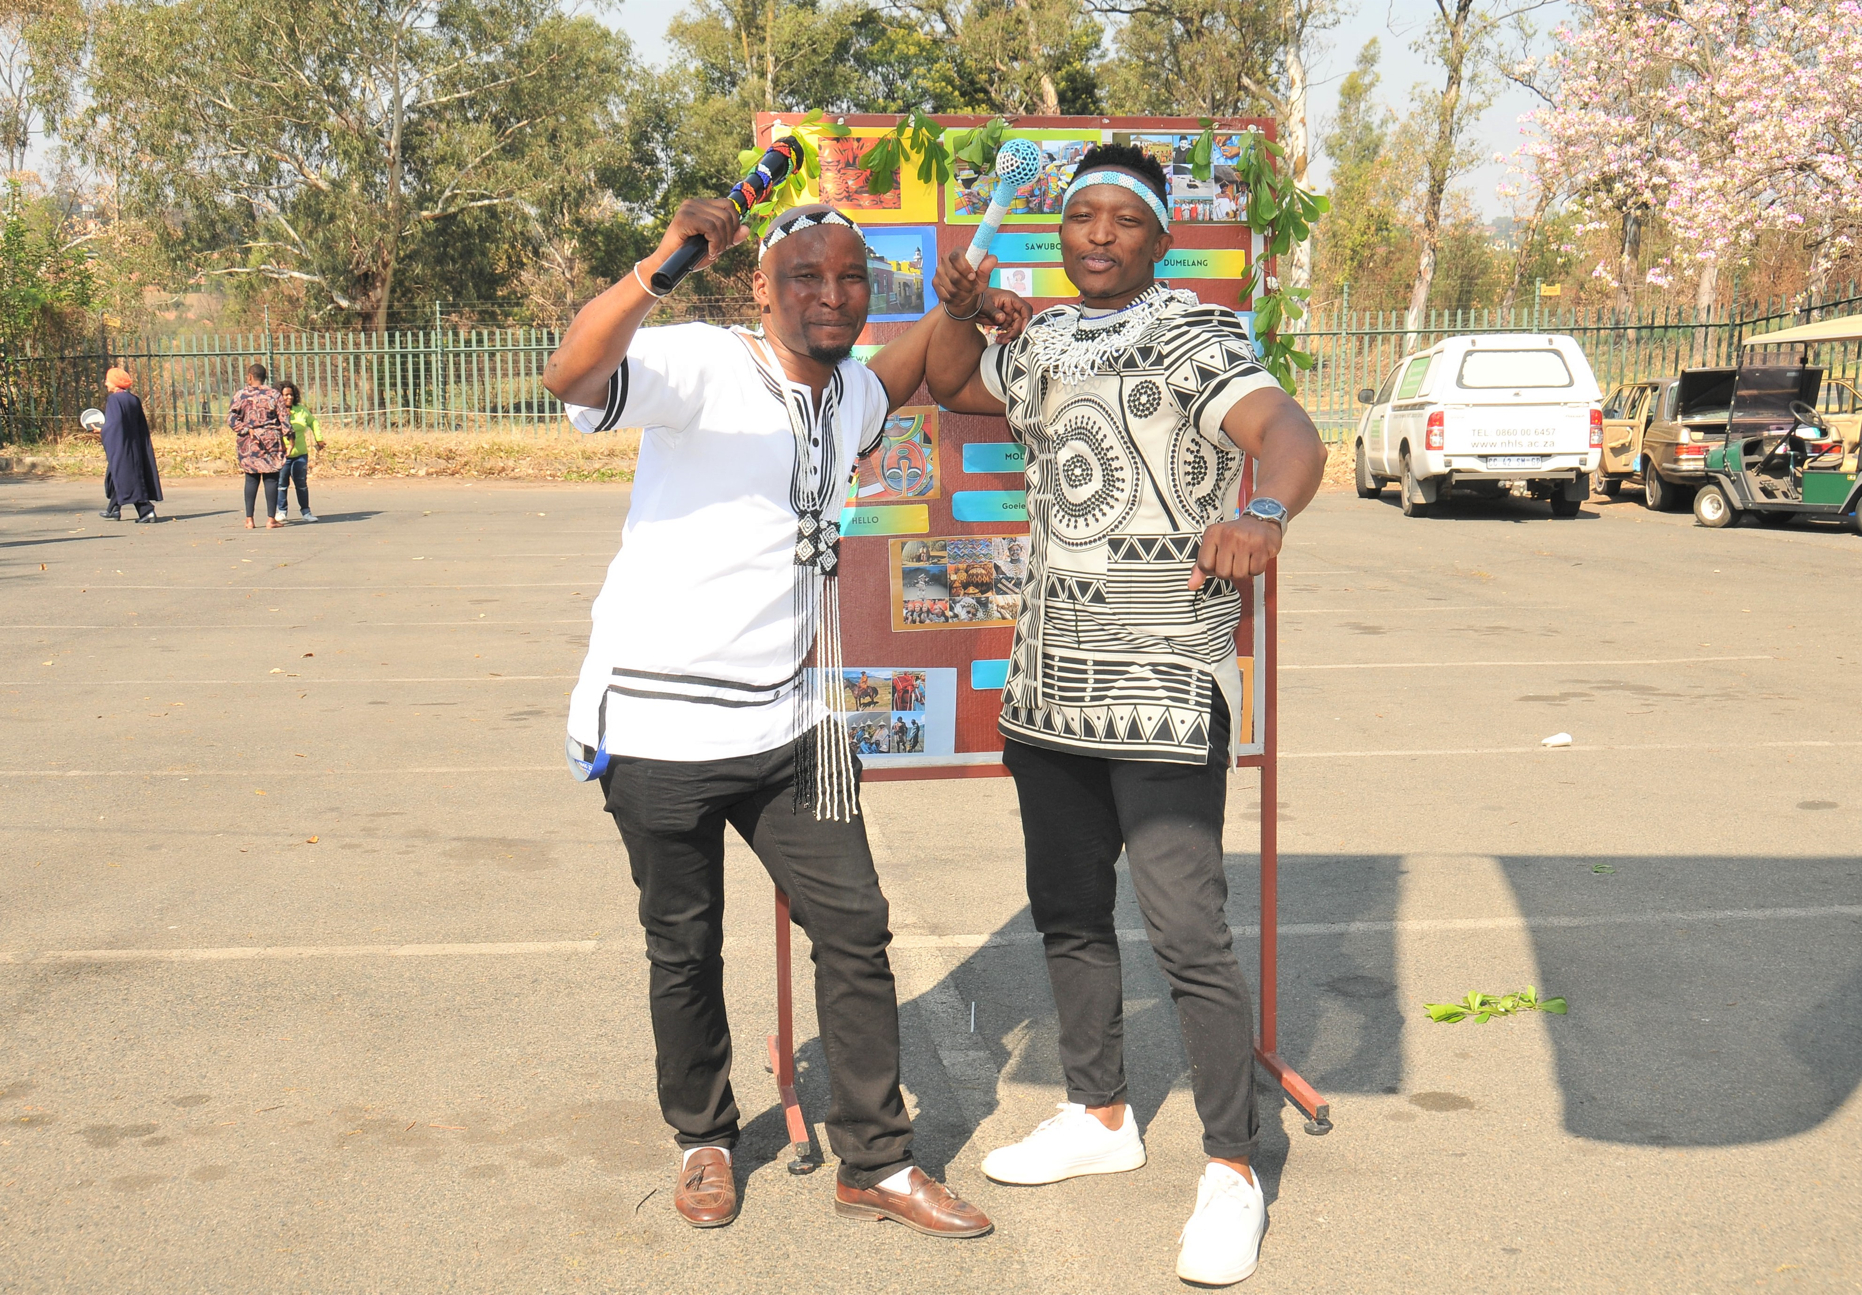

(Pic 73/183)

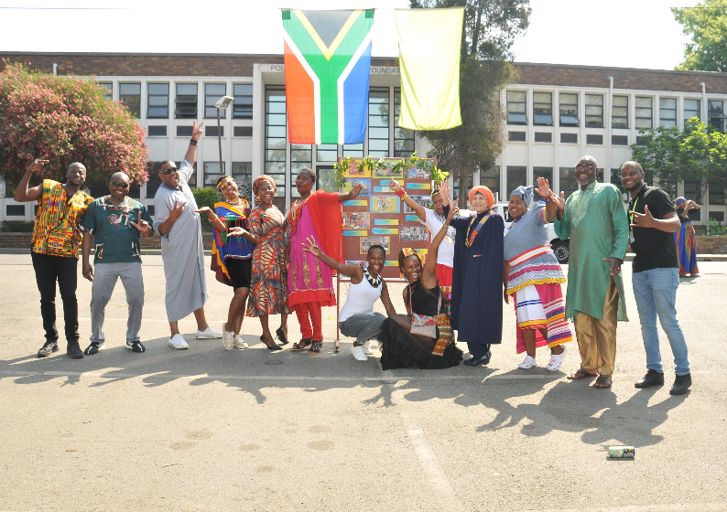

(Pic 150)



(Pic 145)

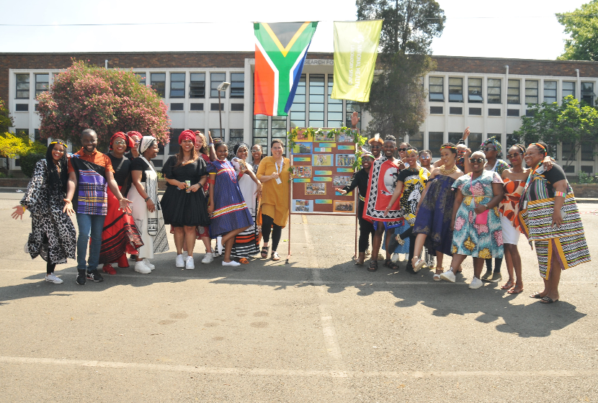

(Pic 143)

