NOTIFIABLE MEDICAL CONDITIONS SURVEILLANCE SYSTEM
the National Institute for Communicable Diseases

Introduction
This report summarizes data from the National Notifiable Medical Conditions Surveillance System (NMCSS) on cases notified during October 2023. Additionally, this report includes information on the distribution of case notifications by sources, such as clinical or laboratory notifications, merged cases (see Appendix no. 3), and the number of reported deaths. It monitors the use of the electronic NMC Reporting Application (App) for notification, data quality, specifically the completeness and timeliness of clinical diagnosis and notifications over time, and back-captured cases notified in October 2023 (see Appendix nos. 1 and 3). Category 4 NMCs, COVID-19, and multi-system inflammatory syndrome (MIS-C) have been excluded from this report.

Highlights
- A total of 12104 cases were notified in October 2023 and the majority were category 2 conditions.
- There were 439 average active users of the NMC App in October 2023
- Category 1 cases were reported in median (IQR) of zero (0, 1) days.

NMC Reporting application
- NMC Reporting App is available on both web and mobile platforms
- Use recommended browsers in order to access NMC reporting App for notifications, searching of cases and reports.
- Register if you have no NMC account and you can reset the password if you have not used the application over 12 months. 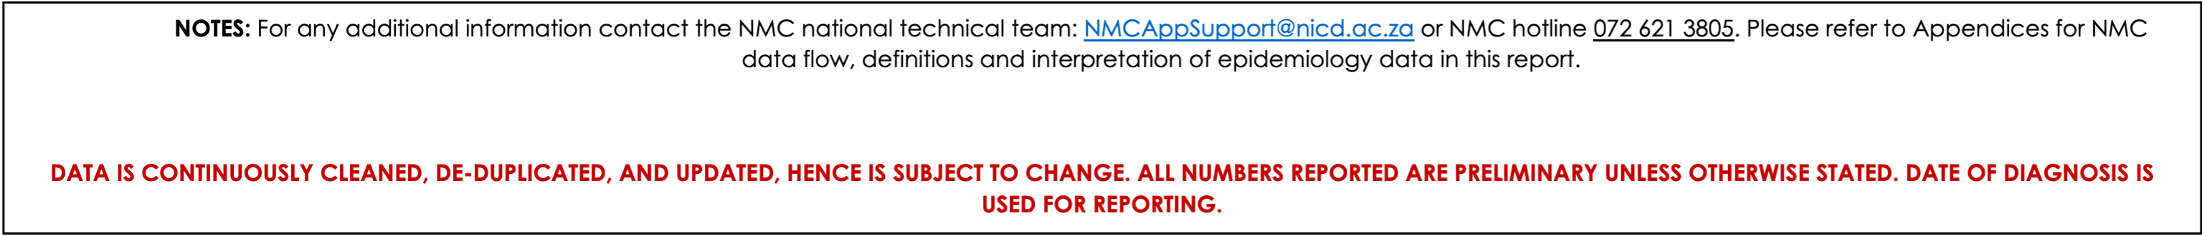

Category 1 Conditions at a glance
Table 1: The number of notifications that are suspected and confirmed for category 1 conditions.
Condition | Suspected/Probable Case,  N = 745¹ | Confirmed Case,  N = 638¹
Acute Flaccid Paralysis | 25 | 0
Cholera | 3 | 0
Congenital rubella syndrome | 0 | 15
Crimean-Congo viral haemorrhagic fever (human) | 0 | 1
Diphtheria | 1 | 1
Enteric fever (typhoid or paratyphoid fever) | 3 | 8
Food borne illness outbreak | 161 | 0
Haemolytic uraemic syndrome (HUS) | 1 | 0
Listeriosis | 1 | 6
Malaria | 114 | 375
Measles | 249 | 44
Meningococcal Disease | 17 | 5
Pertussis | 121 | 96
Rabies | 15 | 0
Rubella | 34 | 87
¹n

NMC data summary, October 2023
A total of n=13187 cases were diagnosed and notified to the NMCSS in October 2023 (See Appendix no.3 for definitions). There were 12104 current notifications; the majority (n=10 597, 88%) were category 2 conditions. The provinces with the highest number of notifications were GP (2 892, 24%), KZN (2 592, 21%), and WC (2 116, 17%). The provinces with the least number of notifications were NC (485, 4.0%), and MP (534, 4.4%). (Figure 1) There were 1083 back captured clinical notifications diagnosed between October, 2013 and October 2023 and only notified in October 2023. The majority (727, 67%) of those notifications were cases TB:pulmonary notifications. (See Appendix no.1).
Table 2: Description of NMC notifications by case source
NMC Category | Overall, N = 12 104 | Clinical notifications,  n = 8976 | Laboratory notifications,  n = 2657 | Merged Cases,  n = 471
Category 1 | 1 383 (11%) | 746 (8.3%) | 427 (16%) | 210 (45%)
Category 2 | 10 597 (88%) | 8 230 (92%) | 2 118 (80%) | 249 (53%)
Category 3 | 124 (1.0%) | 0 (0%) | 112 (4.2%) | 12 (2.5%)

App use
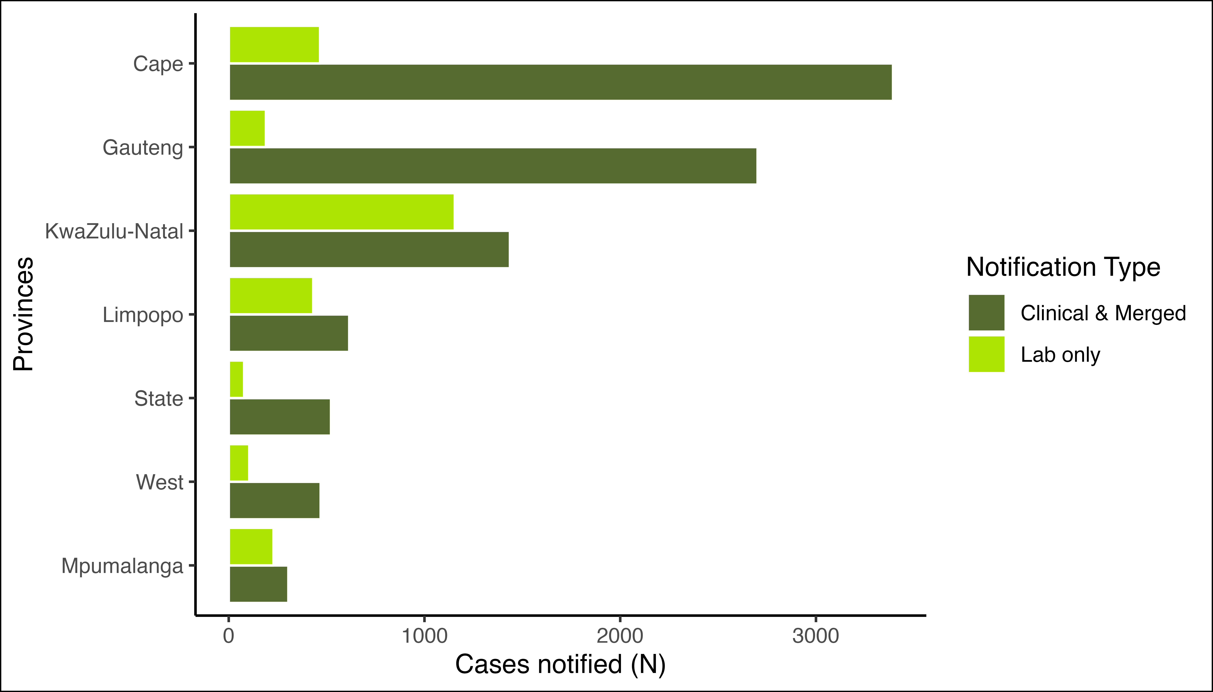
Figure 1: Distribution of notifications by province and notification type
There were 772 (8.2%) Clinical notifications from from the private sector (i.e. private hospitals, private practice and mining industry) compared to 8 674 (92%) in the public sector. Clinical notifications using the NMC Reporting Application made up 8820 (97%) (see Table 3 ).

Table 3: Clinical notifications notified by provinces, reporting platform, and sector
Province | Overall, N = 9 077 | App - Private,  n = 750 | App - Public,  n = 8070 | Paper-based - Private,  n = 19 | Paper-based - Public,  n = 238
GP | 2 626 (100%) | 240 (9.1%) | 2 384 (91%) | 2 (<0.1%) | 0 (0%)
WC | 1 840 (100%) | 132 (7.2%) | 1 605 (87%) | 7 (0.4%) | 96 (5.2%)
KZN | 1 318 (100%) | 139 (11%) | 1 168 (89%) | 4 (0.3%) | 7 (0.5%)
EC | 1 031 (100%) | 58 (5.6%) | 918 (89%) | 4 (0.4%) | 51 (4.9%)
LP | 563 (100%) | 30 (5.3%) | 532 (94%) | 0 (0%) | 1 (0.2%)
FS | 514 (100%) | 51 (9.9%) | 463 (90%) | 0 (0%) | 0 (0%)
NW | 470 (100%) | 31 (6.6%) | 370 (79%) | 0 (0%) | 69 (15%)
NC | 435 (100%) | 27 (6.2%) | 402 (92%) | 0 (0%) | 6 (1.4%)
MP | 280 (100%) | 42 (15%) | 228 (81%) | 2 (0.7%) | 8 (2.9%)

The majority of the notified cases were Males n(%) 7 185 (59%). Individuals in the 35-39 year age group represented the majority (1 420 (12%)) of notified cases (Table 3). At the time of notificaiton, approximately 2 774 (23%) of the notified cases were hospitalized, while 122 (1.0%) were transferred to another healthcare facility. There were 116 deaths notified during the reporting period with case fatality rate of 1.0%.

Hospital Form Completeness
Table 4: Completion of hospitalisation form for notificatiosn reported as inpatients with category 1 conditions. Comlpete refers to >80% of variables completed.
Hospital Form Completed | Complete, n = 20 (4.7%) | Incomplete, n = 100 (24%) | Only Symptoms completed, n = 186 (44%) | Not Attempted, n = 118 (28%)
Acute Flaccid Paralysis | 1 (5.0%) | 6 (6.0%) | 12 (6.5%) | 1 (0.8%)
Cholera | 0 (0%) | 1 (1.0%) | 0 (0%) | 0 (0%)
Congenital rubella syndrome | 0 (0%) | 1 (1.0%) | 0 (0%) | 1 (0.8%)
Diphtheria | 0 (0%) | 1 (1.0%) | 1 (0.5%) | 0 (0%)
Enteric fever (typhoid or paratyphoid fever) | 0 (0%) | 0 (0%) | 2 (1.1%) | 6 (5.1%)
Food borne illness outbreak | 0 (0%) | 6 (6.0%) | 23 (12%) | 9 (7.6%)
Listeriosis | 0 (0%) | 1 (1.0%) | 4 (2.2%) | 0 (0%)
Malaria | 10 (50%) | 29 (29%) | 76 (41%) | 50 (42%)
Measles | 2 (10%) | 15 (15%) | 18 (9.7%) | 4 (3.4%)
Meningococcal Disease | 0 (0%) | 2 (2.0%) | 6 (3.2%) | 9 (7.6%)
Pertussis | 7 (35%) | 38 (38%) | 42 (23%) | 34 (29%)
Rabies | 0 (0%) | 0 (0%) | 2 (1.1%) | 0 (0%)
Rubella | 0 (0%) | 0 (0%) | 0 (0%) | 4 (3.4%)

Distribution of Category 1 NMCs by province and case definition
Table 5: The number of notifications by notification type and the number of notifications that are confirmed by approriate centre.
 | Provinces, n |  |  |  |  |  |  |  |  | Case Definition, n(%)
Condition | EC¹ | FS¹ | GP¹ | KZN¹ | LP¹ | MP¹ | NC¹ | NW¹ | WC¹ | Suspected/Probable Case¹ | Confirmed Case¹
Acute Flaccid Paralysis | 3 | 2 | 2 | 4 | 1 | 1 | 2 | 0 | 10 | 25 (100%) | 0 (0%)
Cholera § | 0 | 0 | 2 | 0 | 0 | 1 | 0 | 0 | 0 | 3 (100%) | 0 (0%)
Congenital rubella syndrome | 0 | 1 | 2 | 4 | 0 | 1 | 0 | 1 | 6 | 0 (0%) | 15 (100%)
Crimean-Congo viral haemorrhagic fever (human) | 0 | 0 | 0 | 0 | 0 | 0 | 0 | 1 | 0 | 0 (0%) | 1 (100%)
Diphtheria * | 0 | 0 | 1 | 0 | 0 | 0 | 0 | 0 | 1 | 1 (50%) | 1 (50%)
Enteric fever (typhoid or paratyphoid fever) | 0 | 0 | 4 | 0 | 1 | 2 | 0 | 1 | 3 | 3 (27%) | 8 (73%)
Food borne illness outbreak | 7 | 1 | 109 | 11 | 1 | 28 | 0 | 4 | 0 | 161 (100%) | 0 (0%)
Haemolytic uraemic syndrome (HUS) | 0 | 0 | 0 | 0 | 1 | 0 | 0 | 0 | 0 | 1 (100%) | 0 (0%)
Listeriosis | 0 | 0 | 1 | 2 | 1 | 0 | 0 | 0 | 3 | 1 (14%) | 6 (86%)
Malaria | 1 | 1 | 92 | 17 | 242 | 102 | 3 | 9 | 22 | 114 (23%) | 375 (77%)
Measles | 9 | 5 | 67 | 17 | 11 | 6 | 12 | 5 | 161 | 249 (85%) | 44 (15%)
Meningococcal Disease | 5 | 2 | 7 | 2 | 0 | 1 | 0 | 0 | 5 | 17 (77%) | 5 (23%)
Pertussis | 14 | 25 | 70 | 33 | 11 | 19 | 4 | 3 | 38 | 121 (56%) | 96 (44%)
Rabies | 1 | 0 | 3 | 1 | 0 | 1 | 9 | 0 | 0 | 15 (100%) | 0 (0%)
Rubella | 3 | 3 | 1 | 2 | 1 | 0 | 14 | 0 | 97 | 34 (28%) | 87 (72%)
¹n(%);
* Toxin producing results not available on NMC;
§ Serotype information not available on NMC;
** Merged case represents a clinical and laboratory notification of the same person and was successfully linked and made into a single notification
The majority of category 1 notifications were for Malaria n(%) 489 (35%). The majority of Malaria cases were notified in LP n(%) 242(49.4%).

Distribution of Category 2 NMCs by province and case definition
Table 6: Distribution of Category 2 NMC by Province
 | Provinces, n |  |  |  |  |  |  |  |  | Case Definition, n(%)
Condition | EC | FS | GP | KZN | LP | MP | NC | NW | WC | Suspected/Probable Case | Confirmed Case
Agricultural or stock remedy poisoning | 6 | 28 | 78 | 0 | 3 | 6 | 0 | 1 | 1 | 123 (100%) | 0 (0%)
Bilharzia (schistosomiasis) | 71 | 1 | 31 | 475 | 284 | 140 | 2 | 4 | 23 | 39 (3.8%) | 992 (96%)
Brucellosis | 0 | 2 | 0 | 0 | 0 | 0 | 0 | 0 | 0 | 2 (100%) | 0 (0%)
Congenital syphilis | 6 | 0 | 3 | 20 | 1 | 2 | 3 | 1 | 19 | 23 (42%) | 32 (58%)
Haemophilus influenzae type B | 8 | 1 | 2 | 2 | 1 | 2 | 2 | 0 | 2 | 16 (80%) | 4 (20%)
Hepatitis A | 29 | 19 | 97 | 103 | 36 | 21 | 15 | 14 | 125 | 74 (16%) | 385 (84%)
Hepatitis B | 114 | 50 | 73 | 705 | 3 | 30 | 19 | 82 | 23 | 142 (13%) | 957 (87%)
Hepatitis C | 0 | 1 | 5 | 0 | 0 | 6 | 0 | 0 | 2 | 13 (93%) | 1 (7.1%)
Legionellosis | 1 | 1 | 1 | 0 | 0 | 0 | 0 | 1 | 2 | 4 (67%) | 2 (33%)
Maternal death (pregnancy, childbirth and puerperium) | 0 | 0 | 6 | 0 | 3 | 1 | 0 | 0 | 0 | 10 (100%) | 0 (0%)
Soil transmitted helminths | 0 | 0 | 1 | 0 | 0 | 0 | 0 | 0 | 0 | 1 (100%) | 0 (0%)
Tuberculosis: extensively drug -resistant (XDR -TB) | 2 | 0 | 4 | 0 | 3 | 1 | 0 | 0 | 1 | 11 (100%) | *
Tuberculosis: multidrug- resistant (MDR -TB) | 46 | 10 | 55 | 37 | 9 | 2 | 8 | 6 | 44 | 217 (100%) | *
Tuberculosis:extra-pulmonary | 142 | 73 | 645 | 228 | 63 | 30 | 47 | 82 | 238 | 1 548 (100%) | *
Tuberculosis:pulmonary | 860 | 422 | 1 908 | 1 131 | 421 | 150 | 446 | 394 | 1 346 | 7 078 (100%) | *
* TB module is under development to align with laboratory confirmed TB cases.
The majority of category 2 notifications were for Tuberculosis:pulmonary n(%) 7 078 (61%). The majority of Tuberculosis:pulmonary cases were notified in GP n(%) 1908(27%).

The average active users on the NMC App

Data quality
Completeness refers to the proportion of complete data entries per variable in the dataset among clinical and merged notifications. In October 2023, there was an increase in completeness of date of diagnosis and patient folder number, while demographic details and patient vital status remain unchanged captured compared to x 2023.
Timeliness is measured by the number of days from the time of diagnosis of the NMC to the time of notification. Overall, it took a median (IQR) of 0.0 (0.0, 1.0) days to report category 1 NMCs.
Table 7: NMC data completeness of clinical notifications on both reporting platforms
 | App, N = 8 820 | Paper-based, N = 258
Folder Number | 7 082 (80%) | 197 (76%)
First Name | 8 820 (100%) | 258 (100%)
Surname | 8 820 (100%) | 258 (100%)
Symptom Onset Date | 8 735 (99%) | 258 (100%)
Date of Diagnosis | 8 820 (100%) | 258 (100%)
Outcome | 8 820 (100%) | 258 (100%)

ID number completeness
Table 8: Length of ID numbers inputted on NMC system
Length of ID number | Android, N = 3 036¹ | Microstrategy/SDW, N = 3 026¹ | Paper-based, N = 258¹ | Web, N = 5 215¹ | iOS, N = 569¹
0 | 1 135 (37%) | 2 918 (96%) | 144 (56%) | 1 623 (31%) | 246 (43%)
1 | 0 (0%) | 1 (<0.1%) | 0 (0%) | 0 (0%) | 1 (0.2%)
6 | 4 (0.1%) | 11 (0.4%) | 0 (0%) | 490 (9.4%) | 55 (9.7%)
7 | 0 (0%) | 0 (0%) | 0 (0%) | 3 (<0.1%) | 0 (0%)
8 | 0 (0%) | 1 (<0.1%) | 0 (0%) | 94 (1.8%) | 2 (0.4%)
9 | 0 (0%) | 0 (0%) | 0 (0%) | 21 (0.4%) | 4 (0.7%)
10 | 0 (0%) | 2 (<0.1%) | 0 (0%) | 107 (2.1%) | 4 (0.7%)
11 | 0 (0%) | 0 (0%) | 0 (0%) | 4 (<0.1%) | 1 (0.2%)
12 | 0 (0%) | 0 (0%) | 0 (0%) | 37 (0.7%) | 0 (0%)
13 | 1 897 (62%) | 93 (3.1%) | 114 (44%) | 2 836 (54%) | 256 (45%)
¹n (%)

Symptomatology
Table 9: Symptoms of patients clinically notified and merged with lab notifications to the NMC
Characteristic | Overall, N = 9 447¹ | Category 1, N = 956¹ | Category 2, N = 8 479¹ | Category 3, N = 12¹
Cough | 4 671 (49%) | 144 (15%) | 4 527 (53%) | 0 (0%)
No Symptoms Reported | 2 847 (30%) | 400 (42%) | 2 435 (29%) | 12 (100%)
Loss of weight | 2 732 (29%) | 0 (0%) | 2 732 (32%) | 0 (0%)
Loss of appetite | 1 943 (21%) | 34 (3.6%) | 1 909 (23%) | 0 (0%)
Night Sweats | 1 729 (18%) | 0 (0%) | 1 729 (20%) | 0 (0%)
Fever | 1 591 (17%) | 250 (26%) | 1 341 (16%) | 0 (0%)
Chest pains | 1 428 (15%) | 0 (0%) | 1 428 (17%) | 0 (0%)
Shortness of breath | 683 (7.2%) | 0 (0%) | 683 (8.1%) | 0 (0%)
Weakness | 619 (6.6%) | 0 (0%) | 619 (7.3%) | 0 (0%)
Flu like symptoms | 571 (6.0%) | 17 (1.8%) | 554 (6.5%) | 0 (0%)
Muscle weakness | 569 (6.0%) | 20 (2.1%) | 549 (6.5%) | 0 (0%)
Other | 480 (5.1%) | 6 (0.6%) | 474 (5.6%) | 0 (0%)
Maculopapular rash | 209 (2.2%) | 209 (22%) | 0 (0%) | 0 (0%)
Conjuctivitis | 105 (1.1%) | 105 (11%) | 0 (0%) | 0 (0%)
Vomiting | 93 (1.0%) | 93 (9.7%) | 0 (0%) | 0 (0%)
Headache | 71 (0.8%) | 71 (7.4%) | 0 (0%) | 0 (0%)
Paroxysmal coughing | 69 (0.7%) | 69 (7.2%) | 0 (0%) | 0 (0%)
Tiredness / Body malaise | 52 (0.6%) | 52 (5.4%) | 0 (0%) | 0 (0%)
Inspirational whoop | 44 (0.5%) | 44 (4.6%) | 0 (0%) | 0 (0%)
Acute febrile illness | 20 (0.2%) | 20 (2.1%) | 0 (0%) | 0 (0%)
Rice-water stools | 1 (<0.1%) | 1 (0.1%) | 0 (0%) | 0 (0%)
Coryza (running nose) | 0 (0%) | 0 (0%) | 0 (0%) | 0 (0%)
¹n (%)

Conclusion
The majority of notifications were clinical notifications. The increase in average active users and newly registered users over time is an indication of an increase in the acceptance of the NMC App in the provinces. The completeness of patient clinical details and patient demographic details have improved, due to the application of mandatory fields on the NMC App. There was a delay in reporting tuberculosis cases. The data harmonization processes between the current and improved NMC system are underway to improve reporting.

Recommendations
- We recommend the expedition of NMC App “whitelisting” on the provincial departmental intranet to make the electronic notification platform more accessible to health facilities.
- We recommend that clinicians should complete all patient clinical and demographic details to improve completeness.
- NMC Trainers to emphasize the importance of timeous reporting of Category 1 and 2 NMCs, in order to ensure real-time availability of data for public health action.

Appendices
Appendix no.1: Back captured clinical notifications
Table 10: Back captured notifications by reporting province
 | Overall | Province |  |  |  |  |  |  |  |  | Case Source
Condition | Overall,  n = 1083 | EC,  n = 91 | FS,  n = 50 | GP,  n = 398 | KZN,  n = 212 | LP,  n = 49 | MP,  n = 23 | NC,  n = 102 | NW,  n = 34 | WC,  n = 124 | Android,  n = 313 | Microstrategy/SDW,  n = 5 | Paper-based,  n = 12 | Web,  n = 711 | iOS,  n = 42
Acute Flaccid Paralysis | 1 (<0.1%) | 0 | 0 | 1 | 0 | 0 | 0 | 0 | 0 | 0 | 1 | 0 | 0 | 0 | 0
Agricultural or stock remedy poisoning | 13 (1.2%) | 0 | 11 | 1 | 0 | 0 | 1 | 0 | 0 | 0 | 0 | 0 | 0 | 12 | 1
Bilharzia (schistosomiasis) | 3 (0.3%) | 0 | 0 | 1 | 2 | 0 | 0 | 0 | 0 | 0 | 1 | 1 | 0 | 1 | 0
Congenital syphilis | 12 (1.1%) | 4 | 0 | 1 | 5 | 0 | 0 | 0 | 0 | 2 | 1 | 1 | 1 | 9 | 0
Hepatitis A | 9 (0.8%) | 1 | 0 | 4 | 1 | 1 | 0 | 0 | 0 | 2 | 2 | 3 | 1 | 3 | 0
Hepatitis B | 28 (2.6%) | 5 | 0 | 10 | 3 | 0 | 8 | 0 | 0 | 2 | 3 | 0 | 0 | 25 | 0
Hepatitis C | 7 (0.6%) | 0 | 0 | 1 | 0 | 0 | 5 | 0 | 0 | 1 | 2 | 0 | 0 | 5 | 0
Malaria | 1 (<0.1%) | 0 | 0 | 0 | 0 | 0 | 0 | 0 | 0 | 1 | 0 | 0 | 0 | 1 | 0
Maternal death (pregnancy, childbirth and puerperium) | 5 (0.5%) | 0 | 0 | 2 | 0 | 2 | 1 | 0 | 0 | 0 | 0 | 0 | 0 | 4 | 1
Measles | 3 (0.3%) | 0 | 0 | 0 | 1 | 0 | 0 | 0 | 0 | 2 | 0 | 0 | 0 | 2 | 1
Meningococcal Disease | 1 (<0.1%) | 0 | 0 | 0 | 0 | 0 | 0 | 0 | 0 | 1 | 0 | 0 | 0 | 1 | 0
Tuberculosis: extensively drug -resistant (XDR -TB) | 2 (0.2%) | 0 | 0 | 2 | 0 | 0 | 0 | 0 | 0 | 0 | 2 | 0 | 0 | 0 | 0
Tuberculosis: multidrug- resistant (MDR -TB) | 38 (3.5%) | 14 | 0 | 5 | 5 | 1 | 0 | 0 | 2 | 11 | 11 | 0 | 0 | 21 | 6
Tuberculosis:extra-pulmonary | 233 (22%) | 9 | 5 | 122 | 55 | 4 | 1 | 10 | 4 | 23 | 39 | 0 | 0 | 187 | 7
Tuberculosis:pulmonary | 727 (67%) | 58 | 34 | 248 | 140 | 41 | 7 | 92 | 28 | 79 | 251 | 0 | 10 | 440 | 26

Appendix no.2: Summary of NMCSS Data Flow
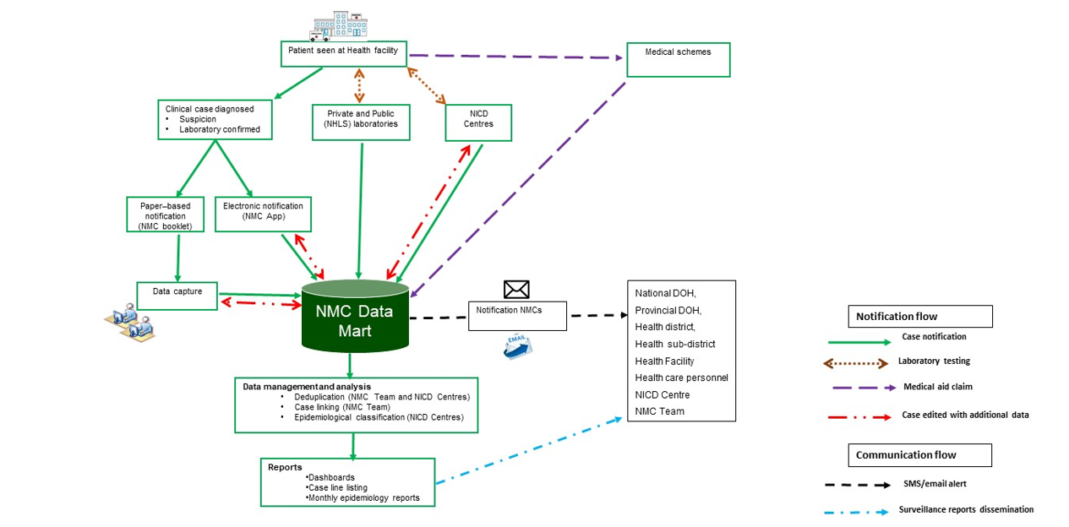

Appendix no.3: NMC Categories, and Case Classification definitions
NMC categories
Category 1: NMCs notified by the most rapid means available upon diagnosis, followed by a written or electronic notification to the Department of Health within 24 hours of diagnosis by healthcare providers, private health laboratories or public health laboratories. These conditions must be notified based on clinical suspicion irrespective of laboratory confirmation.
Category 2: NMCs notified through a written or an electronic notification to the Department of Health of clinical or laboratory diagnosis within 7 days by healthcare providers, private health laboratories or public health laboratories.
Category 3: NMCs notified through a written or electronic notification to the Department of Health within 7 days of diagnosis by public and private health laboratories.
Category 4: NMCs notified through a written or electronic notification to the Department of Health within 1 month of diagnosis by public and private health laboratories.
Case Classification definitions
Clinical case: are cases reported to the NMC by health care providers at facilities, either through completion of a paper form that is faxed, emailed to National Institute of Communicable Diseases (NICD), or by direct data entry into the NMC application on a PC, laptop or mobile device. The diagnosis is made by the clinician on the basis of case definitions published on the NICD website.
Laboratory case: are cases that are downloaded into the NMC database directly from the National Health Laboratory Services (NHLS) laboratory information system. The NMC application applies the case definitions that are published on the NICD website. Private sector data is being sourced.
Merged cases: are cases where a case was notified by health care provider at the facility (a ‘clinical case’) AND the laboratory issued a report with a positive result for the same case (a ’laboratory case). The NMC App is set up to automatically detect and link clinical and laboratory case notifications. The NICD specialist Centres and NMC data team review all cases and manually link any remaining clinical and laboratory cases
Notification capture times definitions
Current notification: All cases diagnosed and notified in the current month
Delayed notification: All cases diagnosed in the last 14 days from the previous month
Back capture notification: All cases diagnosed in previous months and before the last 14 days of the previous month.

Appendix no.4: IDSR reporting template for IDSR conditions existing on NMC by under-5 and 5-and-over years and vital status.
Table 11: The number of IDSR conditions laboratory notified to the NMC using the IDSR reporting template of under and 5-and-above years by vital status.
 | Notified/Suspected |  |  |  | Confirmed
Condition | Under 5 A,  N = 174¹ | 5 & over A,  N = 551¹ | 5 & over D,  N = 7¹ | Under 5 D,  N = 1¹ | N = 638¹
Acute Flaccid Paralysis | 12 | 13 | 0 | 0 | 0
Cholera | 0 | 3 | 0 | 0 | 0
Congenital rubella syndrome | 0 | 0 | 0 | 0 | 15
Crimean-Congo viral haemorrhagic fever (human) | 0 | 0 | 0 | 0 | 1
Diphtheria | 0 | 1 | 0 | 0 | 1
Enteric fever (typhoid or paratyphoid fever) | 0 | 3 | 0 | 0 | 8
Food borne illness outbreak | 12 | 146 | 1 | 0 | 0
Haemolytic uraemic syndrome (HUS) | 0 | 1 | 0 | 0 | 0
Listeriosis | 0 | 1 | 0 | 0 | 6
Malaria | 6 | 103 | 5 | 0 | 375
Measles | 94 | 155 | 0 | 0 | 44
Meningococcal Disease | 2 | 15 | 0 | 0 | 5
Pertussis | 36 | 75 | 1 | 1 | 96
Rabies | 0 | 15 | 0 | 0 | 0
Rubella | 12 | 20 | 0 | 0 | 87
¹A = Cases who are alive.
D = Cases who are deceased.

END

